
WICKFORD HARBOR CRUISES

FOR ADULTS & SENIORS
Brandaris Maritime welcomes adults aboard for a series of fun cruises out onto Narragansett Bay. Enjoy cool sea breezes and the traditional New England charm of Wickford’s harbor in comfort.

Let the staff of Brandaris Maritime arrange an afternoon or evening of recreation suited to your groups’ interests. Take a scenic lighthouse tour. Play games. Eat ice cream. Listen to live music by local talents. Enjoy a picnic lunch or perhaps a special dessert.

Our outings last for two hours and depart Wickford Town Wharf, located at the end of Main Street. The crew aboard our motor vessel Sea Princess and the harbor launch General are dedicated to offering safe and easy access to beautiful Narragansett Bay.
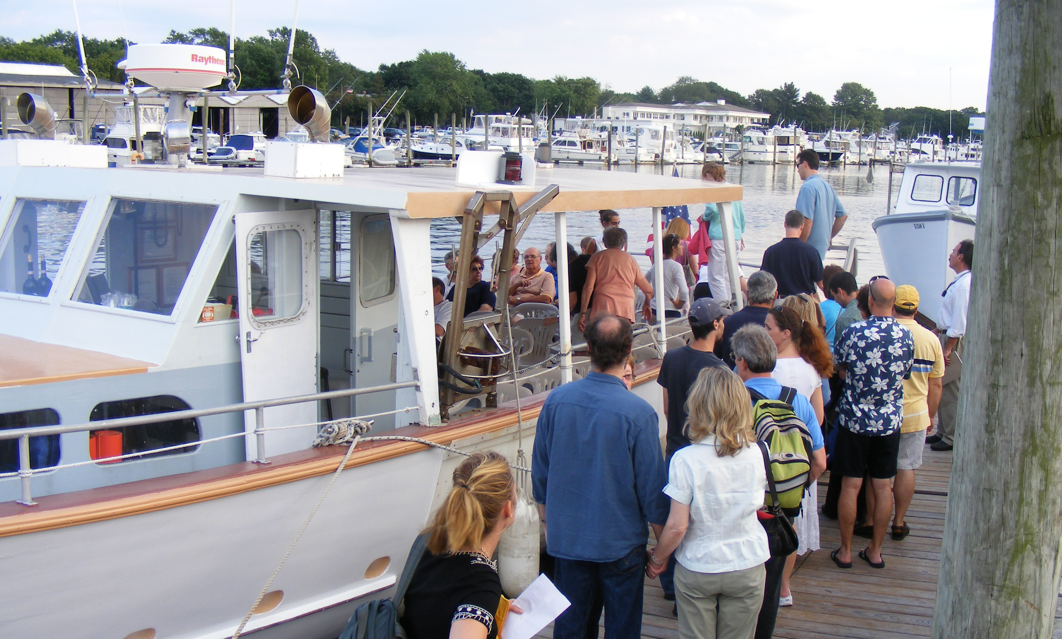

Brandaris Maritime
39 Ocean Avenue, Wickford, R.I. 02852
401-294-0021 or 401-294-1481
info@brandarismaritime.com www.brandarismaritime.com
WICKFORD HARBOR CRUISES
FOR GROUPS

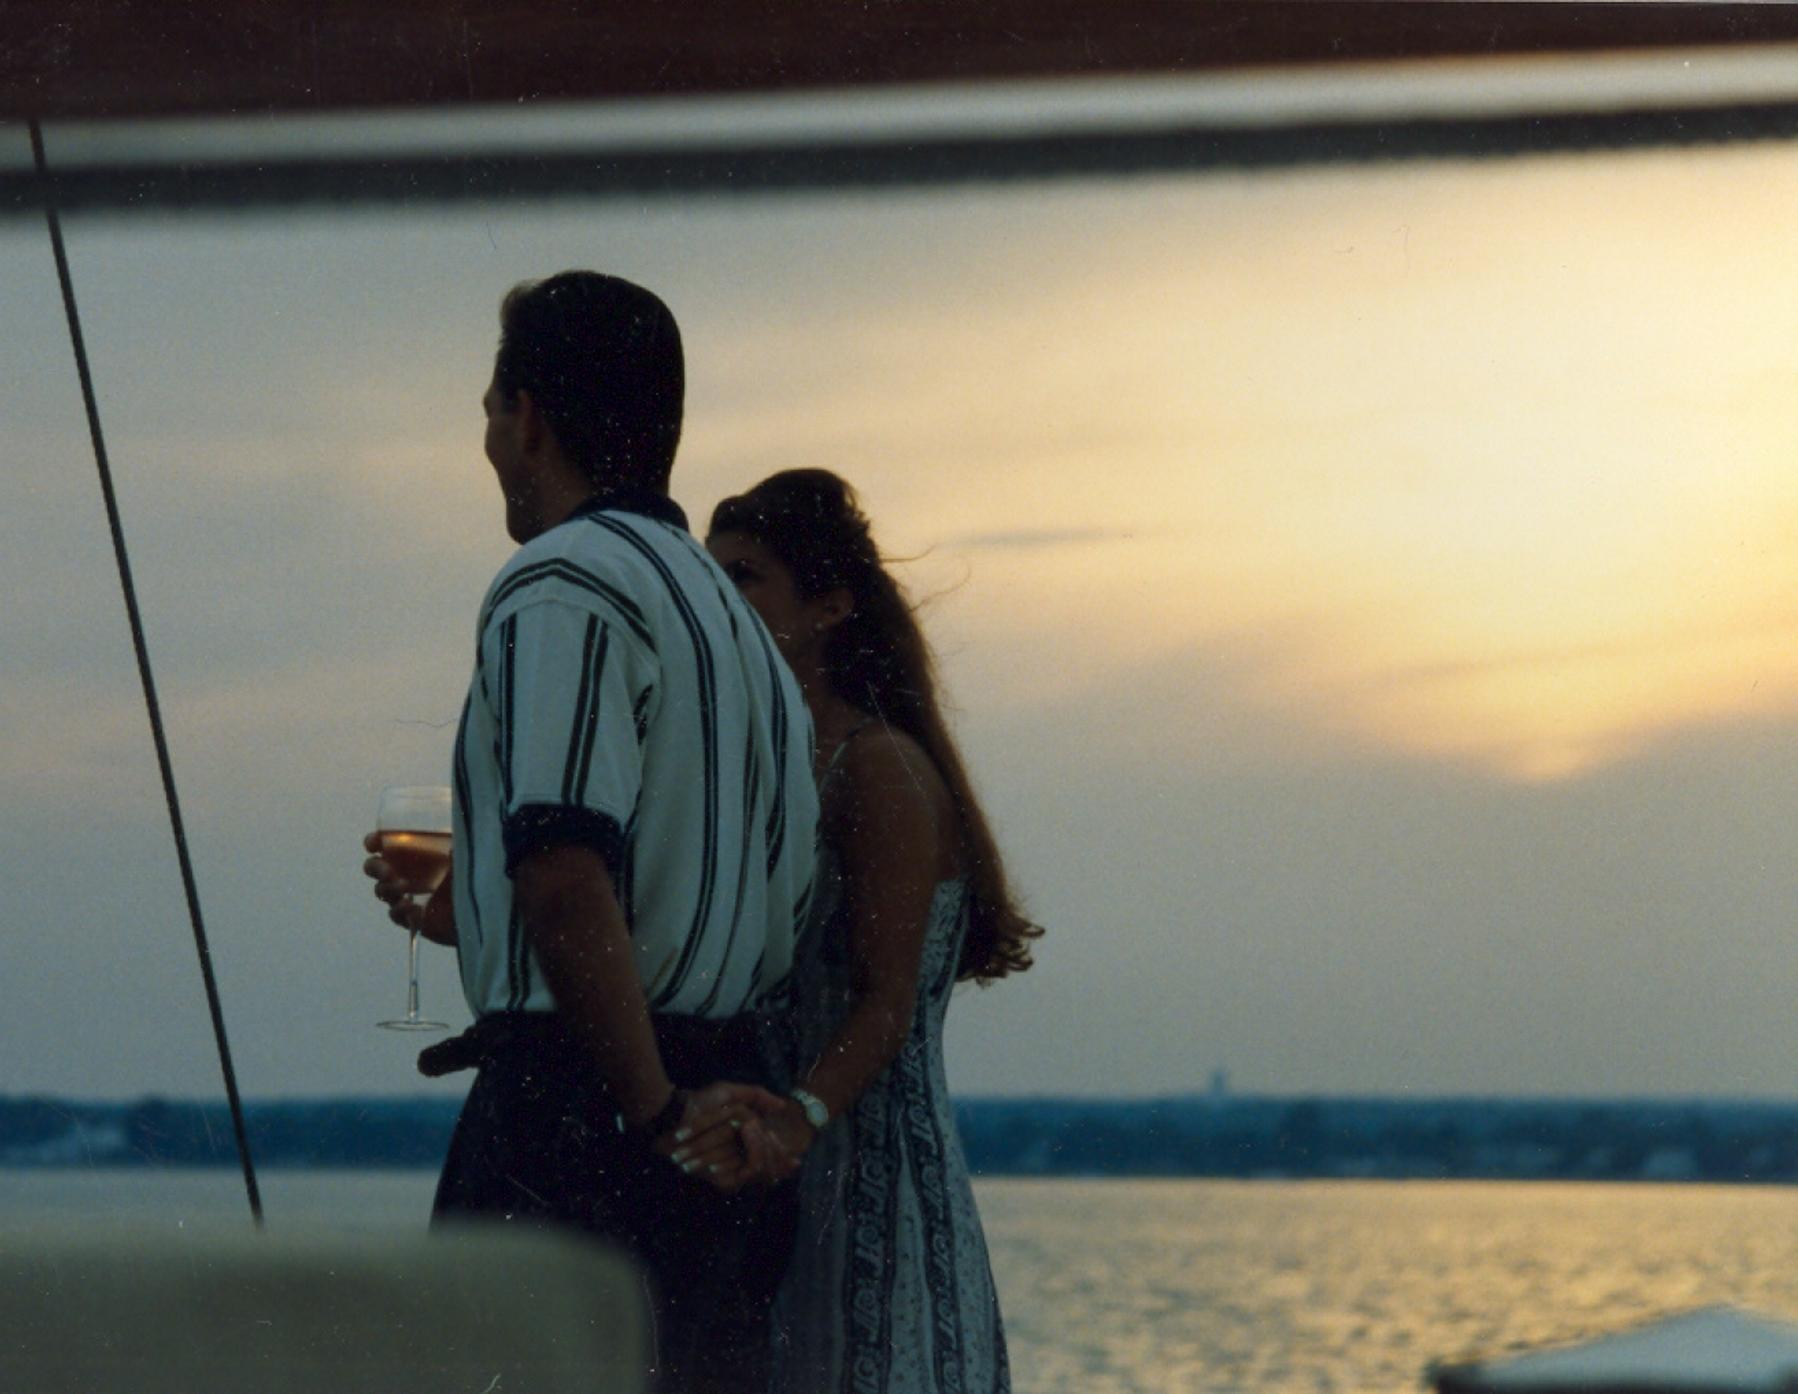

Our most popular themes are:

- A Lighthouse Cruise – lighthouses of West passage
- Dessert Cruise - Ice Cream (from the Inside Scoop)
- Bingo on the Bay - and other games underway
- Music Cruises - with live local musician onboard
- Picnic on the Bay - for lunch or early supper while underway
- Wine Tasting – add some hors d’oeuvres
Charter Reservation Details
Group Size:

Aboard Sea Princess - Minimum 20 guests / Maximum 35
Aboard General - Minimum 10 guests / Maximum 20

Pricing:

Give our program planners a call at 294-0021. We are happy to provide details on the enhanced program and help you design a program tailored for your group. We consider the needs of the very elderly and adjust our program, as required.

Brandaris Maritime
39 Ocean Avenue, Wickford, R.I. 02852
401-294-0021 or 401-294-1481
info@brandarismaritime.com www.brandarismaritime.com

